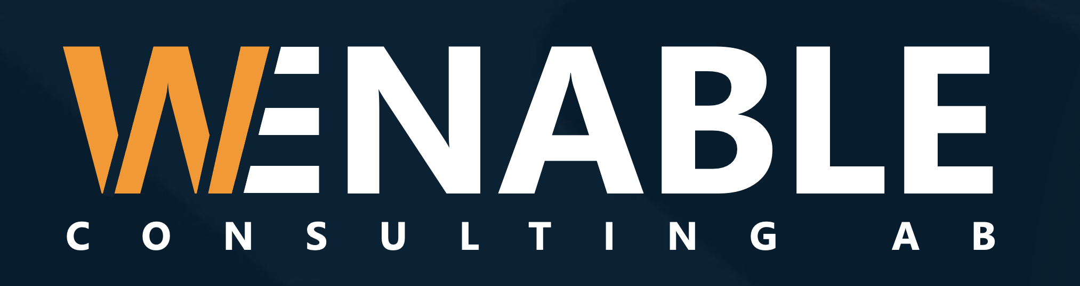
Erik Lindqvist
Senior AI & Cybersecurity Consultant
Gothenburg, Sweden · erik.lindqvist@wenable.se · +46 70 412 88 30 · Available Q4 2026
Professional summary
Erik is a senior specialist consultant with more than twelve years spent at the intersection of applied artificial intelligence and cybersecurity, working almost exclusively with regulated, security-sensitive organisations. He designs and ships production AI and data platforms, then makes sure they hold up under real-world threat models, audit scrutiny and compliance pressure — closing the gap that usually opens between a promising prototype and a system the business can actually trust in production.
He is equally effective in a target-architecture review, an executive risk briefing, or hands-on at the keyboard delivering the work himself. Clients engage Erik when the stakes are high and the problem sits across disciplines: a large language model that has to pass model-risk governance, a critical-infrastructure platform that has to be secure by design, or a data estate that has to be both fast and defensible. He is known for raising the standard of the teams he joins and leaving them more capable than he found them.
Key strengths
- Production LLM and retrieval-augmented systems that clear model-risk and governance review.
- Secure-by-design architecture for critical infrastructure and regulated data.
- Cloud and data platform engineering across Azure and AWS at scale.
- Trusted technical advisor to executive and board-level stakeholders.
- Pragmatic delivery leadership — mentoring client teams while shipping working software.
Technical skills
Languages Python, Go, SQL, TypeScript
AI / ML PyTorch, Hugging Face, LangChain, RAG architectures, vector databases, MLOps
Cloud & data Azure, AWS, Kubernetes, Terraform, Snowflake, Apache Kafka
Security NIST CSF, ISO 27001, threat modelling, OT/IT security, IAM, DevSecOps
Governance EU AI Act readiness, model-risk management, secure-by-design review gates
Professional experience
Principal Consultant — AI & Security
Wenable Consulting AB, Gothenburg 2021 – Present
- Leads cross-disciplinary AI and security engagements for banking, energy and public-sector clients, from architecture through to production delivery.
- Delivered a retrieval-augmented LLM assistant for a Nordic bank that cut analyst handling time by 38% while clearing internal model-risk review.
- Designed the secure MLOps backbone (Azure, Kubernetes, Terraform) now reused as a standard pattern across three client engagements.
- Acts as trusted advisor on AI governance and threat modelling for two listed clients.
Lead Security Architect
Nordsec Defence Systems 2017 – 2021
- Owned the target security architecture for a critical-infrastructure SCADA modernisation programme.
- Established the secure-by-design review gate subsequently adopted across the engineering organisation.
- Built and led a small architecture guild, mentoring six engineers toward senior level.
Senior Software Engineer
Volvo Group — Connected Solutions 2013 – 2017
- Built streaming data pipelines and anomaly-detection services for a connected-vehicle fleet of 400,000+ units.
- Introduced the team’s first production machine-learning models for predictive maintenance.
Selected assignments
LLM Knowledge Assistant — Nordic Tier-1 Bank
AI / Applied LLM · Lead Engineer & Architect · 14 months
Context. The bank needed to give thousands of analysts faster, governed access to a sprawling body of internal policy and product documentation, without exposing the organisation to hallucination or compliance risk.
Contribution
- Designed the end-to-end retrieval-augmented generation architecture, including ingestion, embedding and access-controlled retrieval.
- Built the evaluation harness and guardrails required to satisfy the bank’s model-risk function.
- Partnered with compliance to produce the audit trail and documentation for sign-off.
Technologies. Python, LangChain, Azure OpenAI, vector database, Kubernetes, Terraform
Outcome. Cut average analyst handling time by 38% and became the first generative-AI system approved for production use at the bank.
OT/IT Threat Modelling — National Energy Utility
Cybersecurity · Lead Security Architect · 6 months
Context. A national utility was modernising operational technology that had historically been air-gapped, and needed to understand the new attack surface before connecting it to corporate IT.
Contribution
- Ran end-to-end OT/IT threat-modelling workshops across the engineering and security teams.
- Produced a prioritised hardening roadmap mapped to the NIST Cybersecurity Framework.
- Defined the segmentation and monitoring architecture for the converged environment.
Technologies. NIST CSF, threat modelling, network segmentation, IAM
Outcome. Delivered a board-approved roadmap that de-risked the modernisation and set the security baseline for the programme.
Cloud Data Platform — Medtech Scale-up
Platform Engineering · Principal Engineer · 9 months
Context. A fast-growing medtech company had outgrown its early data stack and needed a scalable, compliant platform without slowing the product teams down.
Contribution
- Architected a Snowflake and streaming-based data platform with clear data-governance boundaries.
- Built the developer experience — self-service pipelines, CI/CD and observability — around it.
- Coached the in-house team to own and extend the platform after handover.
Technologies. Snowflake, Apache Kafka, AWS, Terraform, dbt
Outcome. Reduced data-pipeline lead time from weeks to days and gave the company an auditable, compliant data foundation.
AI Governance Framework — Public-Sector Agency
Advisory · AI Governance Lead · Ongoing
Context. A public-sector agency wanted to adopt AI responsibly and needed a practical framework aligning deployment with the incoming EU AI Act.
Contribution
- Developed a risk-tiered governance framework mapped to the EU AI Act.
- Established review gates and documentation standards for model deployment.
- Trained internal stakeholders to apply the framework independently.
Technologies. EU AI Act, model-risk management, governance design
Outcome. Gave the agency a defensible, repeatable process for approving and operating AI systems.
Education
M.Sc. Computer Science & Engineering 2011 – 2013
Chalmers University of Technology, Gothenburg
B.Sc. Computer Science 2008 – 2011
University of Gothenburg
Certifications & languages
Certifications AWS Solutions Architect – Professional (2024) · CISSP (2022) · Azure AI Engineer Associate (2023) · Certified Kubernetes Administrator (2021)
Languages Swedish (native) · English (fluent, C2) · German (professional, B2)
References available on request.
Wenable Consulting AB Org. nr 559571-3164 · Gothenburg, Sweden · wenable.se

